How to Use SANBORN MAPS
(updated July 2018)

Fire insurance maps are among the most useful tools to track the historical development of a property or neighborhood. In use long before the availability of aerial photographs, fire insurance maps often recorded important information about commercial and institutional buildings and residences, including dates of construction, structural and exterior materials, building uses, and lot sizes. The most prolific producer of fire insurance maps was the Sanborn Map Company of Pelham, New York, which traced the evolution of thousands of United States cities and towns, including more than 400 in Texas. Sanborn maps can be used to establish exact or estimated dates of construction and alterations for buildings and structures. When used with other historical records, such as photographs, deed records and newspaper articles, Sanborn maps can help document the history of a property.

GETTING STARTED
- The TexShare program (https://www.tsl.texas.gov/texshare/index.html) provides access to many of the state’s historic Sanborn maps. You must request a login for the TexShare databases from your local public library. You can find the nearest participating library on the Texas State Library website at https://www.tsl.texas.gov/findalibrary. The library will instruct you on how to log in and access the Sanborn maps. If you have questions or any difficulty getting access to the TexShare databases, you may contact the Texas State Library at TexShare@tsl.texas.gov.
- The subsequent web page lists dozens of TexShare online resources, including the Handbook of Texas Online, newspaper article searches and other educational tools. Under the heading History and Genealogy, click on the Texas Digital Sanborn Maps link. This will give you access to all the digitized Sanborn maps for Texas.

FINDING THE LOCATION
- Select State: Texas is the only choice in the pulldown menu.
- Select City: Sanborn maps have been digitized for 436 Texas cities and towns, including most county seats. To see if your community has historic Sanborn maps, click on the arrow for the pulldown menu and scroll through the list, which is alphabetized by city and also includes county names.
- Select Date: Your community may have had from one to a dozen Sanborn maps produced during the late 19th and early 20th centuries. Click on the arrow for the pulldown menu to see which dates are available and choose the one that meets your research needs.
- Choosing a city and date takes you to the next page, which displays available map sheets in thumbnail views. The first sheet in each city is usually an index sheet, indicating which following sheets cover specific parts of the city, both in map and street index form.
- Choose the sheet which includes your property by clicking on it. This opens the scanned image in a new window, with different window sizes and zoom levels available. You can change the zoom level using the pulldown menu or by clicking on a specific part of the image. There is also a button to help re-center the image.
DOWNLOADING OR PRINTING THE MAP
- When you have the portion of the image you need on the screen, you can download or print the image. Clicking “Download Map” saves the image as a .pdf file, which you can then copy or edit as you need using imaging programs.
- To print the image, select “Print Current View” from the top of the screen. This opens a new window with the image as chosen on the screen. You can then set your printer properties to print the image.

ADDITIONAL NOTE
- Original Sanborn maps have some information not included in the digitized copies, including color coding to indicate building materials such as stone, brick or wood. Large collections of original Sanborn maps are available at the University of Texas at Arlington Libraries (https://library.uta.edu/), the Dolph Briscoe Center for American History (http://catalog.lib.utexas.edu/) and the Perry-Castañeda Map Library (https://legacy.lib.utexas.edu/maps/sanborn/texas.html) at the University of Texas at Austin, and the Southwest Collection at Texas Tech University (https://guides.library.ttu.edu/c.php?g=710208). Some collections include original maps which are not available in digital format.

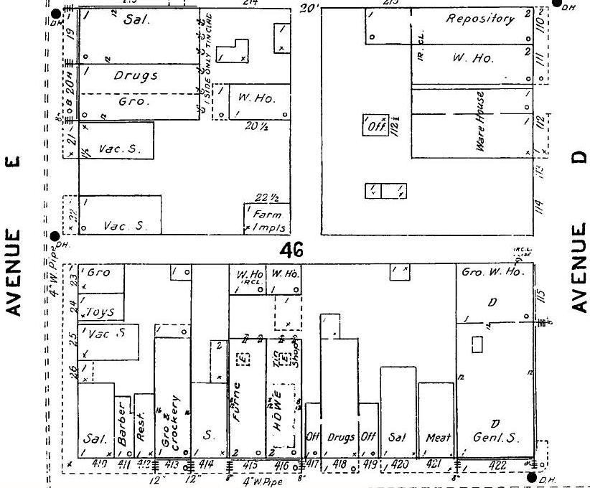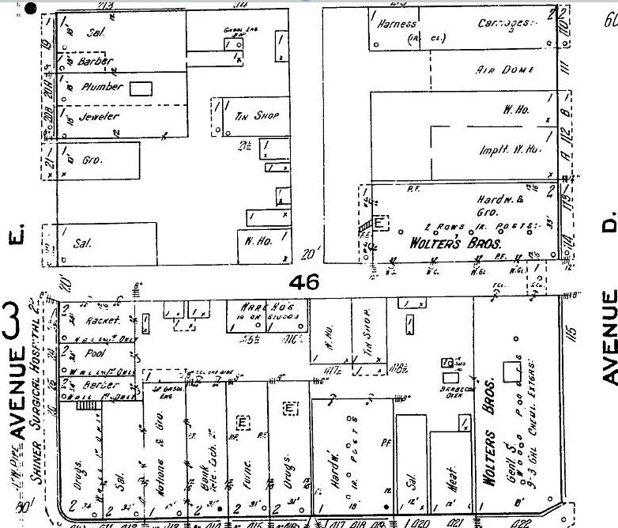
Shiner 1906 Shiner 1912

By comparing Sanborn images of a block of buildings in the town of Shiner, we see that Wolters’ Brothers hardware and grocery store appears in the center of the second image but not in the first. This narrows down the year of construction for the building to 1906-12, which helps limit the search for other records, such as deeds, tax rolls, photographs and newspaper accounts. The images also show evidence of other new structures and changes to existing buildings. Images available through the Texas State Library Texshare database.
Texas Historical Commission
History Programs Division
P.O. Box 12276, Austin, TX 78711-2276
Phone 512/463-5853 Fax 512/475-3122
Email history@thc.state.tx.us
www.thc.state.tx.us

Texas Historical Commission
History Programs Division
P.O. Box 12276, Austin, TX 78711-2276
Phone 512/463-5853
history@thc.texas.gov

