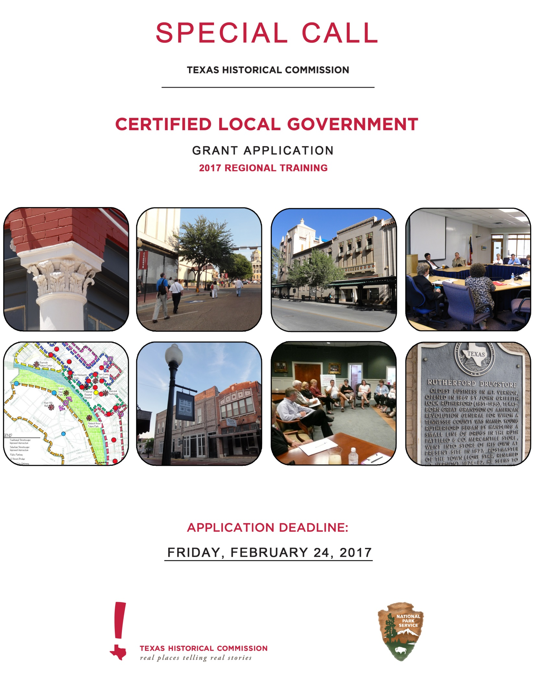

This grant manual has been financed in part with Federal funds from the National Park Service, U.S. Department of the Interior and administered by the Texas Historical Commission. However, the contents and opinions do not necessarily reflect the views or policies of the Department of the Interior.

This program receives federal financial assistance for identification and protection of historic properties. Under Title VI of the Civil Rights Act of 1964 and Section 504 of the Rehabilitation Act of 1973, and the Age Discrimination Act of 1975, as amended, the Department of the Interior prohibits discrimination on the basis of race, color, national origin, or disability or age in its federally assisted programs. If you believe you have been discriminated against in any program, activity, or facility as described above or you desire further information, please write to:

Office for Equal Opportunity
National Park Service
1849 C Street, N.W.
Washington, D.C. 20240

INTRODUCTION
Certified Local Government (CLG) grants provide funding to participating city and county governments to develop and sustain an effective local preservation program critical to preserving local historic resources. The Texas Historical Commission (THC), the state agency for historic preservation, administers the Texas CLG grant program utilizing federal funding it receives from the U.S. Department of Interior, National Park Service (NPS) Historic Preservation Fund Program. Under this program the NPS requires that at least ten percent (10%) of Texas' annual federal allocation be sub-granted exclusively to participating Certified Local Governments (CLGs). The program serves as a great resource for participating county and city governments to offset the costs of self-sustaining preservation and planning-related projects. Currently, there are 74 CLGs in Texas.

Due to unexpected circumstances, funds designated in the FY16 cycle have been returned to the THC. In order to meet federal requirements, these funds must be expended by September 2017. Therefore, the THC is seeking applications from qualified CLG communities to host a regional training.

The THC envisions one or more regional trainings around the state in partnership with the selected host CLG(s), the Friends of the Texas Historical Commission (FTHC), and the National Alliance of Preservation Commissions (NAPC). The grant would fund a one day or one-and-a-half day Commission Assistance and Mentoring Program (CAMP) training for individuals who play an active role in a CLG’s historic preservation program. This includes, but may not be limited to, Historical Commission members, Planning Board/Commission members, elected officials, and city or county staff (e.g. Historic Preservation Officers (HPO), city managers, code officials, planners, administrative assistants).

The goal of CAMP trainings is to provide high-quality, engaging and informative training to preservation related boards and commissions of all types through presentation, hands-on exercises, group discussions and networking (mentoring) opportunities. Trainers include commissioners, local, state and national staff members, attorneys and commission partners.

The THC will work with NAPC and the host CLG(s) to develop the content of the training. FTHC will be the fiscal manager of the project, will receive the grant funds on behalf of the host CLG(s), and will contract with NAPC and/or other content providers for the training.

All individuals who play an active role in a Texas CLG will be invited to register for this regional training.

All trainings will take place before September 30, 2017.

The selected CLG(s) will enjoy hosting the training in their own community and will be awarded seven (7) comped registration fees.

WHO MAY APPLY
Only city, county governments or state recognized Native American Tribes that have been individually "certified" by the National Park Service before January 2017 are eligible to apply for CLG grants. Refer to http://www.thc.texas.gov/preserve/projects-and-programs/certified-local-government/certified-local-government-communities for a complete list of all CLGs in Texas. The Texas Historical Commission reserves the right to deem applications from CLG communities that are not in compliance with the Certification Agreement to be ineligible. (Should you wish to verify compliance in advance of submitting an application please contact Ginny Owens at Virginia.owens@thc.texas.gov.)

REQUIRMENTS OF THE SELECTED CLG(s)
The participating CLG(s) will not be required to provide local matching funds; however local CLG staff will be required to work with the THC and NAPC to support the training. The host CLG is responsible for the following:
- Provide a meeting space that can accommodate 50-60 people
- Provide morning and afternoon refreshments (coffee, water, snacks, etc.)
- Provide audio visual equipment in the space provided (screen, computer, projector, etc.)
- Assistance with advertising the training regionally
- Work with THC and NAPC on other program logistics as needed
- Provide lunch (not required; however, bonus points will be awarded to CLGs that can provide lunch)

The host CLG is not responsible for the following:
The CLG will not be responsible for managing the content of the training. All content, invited speakers, and schedule will be coordinated by the THC and NAPC; the host CLG may be consulted.

The CLG will not be responsible for processing registrations for the event.

APPLICATION AND SELECTION PROCESS

Only CLGs who have submitted a FY16 Annual Report will be considered eligible.

Higher consideration will be given to CLGs that are located near a concentration of other CLG communities, have the staff and/or volunteers to help manage this grant project within the accelerated timeframe, who are in good standing meeting reporting requirements, and have not received a CLG grant to host a local training in the past five years. (This does not include travel stipends to attend FORUM16.)

Bonus points will be awarded to CLGs who can provide lunch during the training. Lunch will be at the site of the training (i.e. box lunch, buffet, etc.).

The applications will be reviewed and evaluated by THC staff. THC will consider need, geographic distribution, and the capacity of the CLG to host the training in selecting applicants. Capacity to host the CAMP training will be evaluated using the responses to Questions 1 and 2 on the application form. Need will be evaluated using Question 3.

Please submit one completed application form via email. The application must be signed by the HPO or CLG Representative and the chief elected official of the CLG (e.g. Mayor or Judge) or chief administrative official (e.g. City Manager).

Applications must be signed, scanned and emailed to the THC on or before February 24, 2017 by 5pm. Please submit all applications to: madeline.clites@thc.texas.gov

QUESTIONS

Contact Madeline Clites, Certified Local Government Coordinator at 512-463-9063 and madeline.clites@thc.texas.gov or Laura Camayd, Local Government Specialist at 512-463-7812 and laura.camayd@thc.texas.gov with any questions about the this special call for grant applications.

Grant timeline

February 24, 2017 Deadline for receipt of applications and any supporting materials to THC no later than 5 p.m. Friday, February 24, 2017.

March 2017 Review of applications by THC staff interdisciplinary committee.

Early May 2017 THC sends Preliminary Notification to grant recipients that will include grant contract.

Late May 2017 Deadline for submittal of signed contracts, final project proposals, budgets, etc. from selected applicants to THC no later than 30 days from the date of Preliminary Notification letter.

September 30, 2017 Deadline for the completion of all work eligible for reimbursement.

CERTIFIED LOCAL GOVERNMENT SUBGRANT
FISCAL YEAR 2017 GRANT APPLICATION FORM
Special Call for Regional Training

Deadline for submission is by 5pm on February 24, 2017
Please fill out this section completely and use only the space provided below.

Name OF PROPOSED PROJECT: CLG Regional Training

Certified Local Government Name:

CONTACT INFORMATION: |  |  | Project Manager |  |  |  |  |  | Fiscal Manager
Organization Name |  |  |  |  |  |  |  |  | Friends of the Texas Historical Commission
Contact Person |  |  |  |  |  |  |  |  | Anjali Kaul Zutshi
Address |  |  |  |  |  |  |  |  | P.O. Box 13497
City | State | Zip |  |  |  |  |  |  |  |  | Austin | TX |  | 78711
Telephone | Fax |  |  |  |  |  |  |  |  | 512-936-2241
Email |  |  |  |  |  |  |  |  | Anjali.zutshi@thc.texas.gov
Political Contacts: |  | Historic Preservation Officer, Chair of Local Commission, or  CLG Representative* |  |  |  |  |  |  | City Mayor or County Judge
Contact Person
Address
City | State | Zip
Telephone | Fax
Email
* May be the same contact as Project Manager

- Event Details:
- Preferred date and back-up date for a 1.5 day training. The training must take place between July 1, 2017 and September 30, 2017.
Example: Preferred: July 13 all day, July 14 half day Back-Up: July 17 all day, July 18 half day

- Proposed meeting space information (historic site downtown preferred; include information such as name, address, parking, facilities, capacity, etc.):
- Plan to provide morning and afternoon refreshments (vendor, menu, delivery or pick-up responsibilities, etc.):

2. Why would your community be an excellent location for the regional training? Please describe the CLG’s capacity to host such an event (i.e. staff support, adequate meeting space and equipment, sourcing of refreshments, etc.)

3. What challenges does the local preservation program face? How would additional training help to address these challenges? Please be as specific as possible.

4. Did the CLG submit an FY16 Annual Report? (Yes or No)

5. BONUS POINTS: Providing lunch is not a requirement of the host CLG; however, during the scoring process extra points will be awarded to CLGs who are able to provide a simple and modest lunch at the training site. Box lunches or a simple buffet would be ideal. Please describe the CLG’s plans to provide lunch in the space below. For example, include the name of the vendor and proposed menu. If the CLG does not wish to provide lunch, please leave this section blank.

ACKNOWLEDGEMENTS - By checking below the applicant acknowledges:

☐ | A signed and completed application will be scanned and emailed to madeline.clites@thc.texas.gov by February 24, 2017 by 5pm.
☐ | The CLG host community must provide a meeting space that can accommodate 50-60 people
☐ | The CLG host community must provide refreshments (coffee, water, snacks, etc.) in the morning and afternoon for each day of the training.
☐ | The CLG host community must provide audio visual equipment in the space provided (screen, computer, projector, etc.)
☐ | Applications received from CLGs that have not submitted a FY16 Annual Report will not be reviewed.
☐ | Incomplete applications will not be reviewed.
☐ | Late applications, faxed applications, and hand written applications will not be reviewed.
☐ | The information provided on this application is accurate to the best of your knowledge.

Applicant’s Certification: Application must be signed by legal CLG representative.

Signature: ___________________________ Title: ______________________ Date: ______________

Chief Elected official Certification: Application must be signed by the chief elected official of the CLG (e.g. Mayor or Judge) or chief administrative official (e.g. City Manager).

Signature: ___________________________ Title: ______________________ Date: ______________

CERTIFIED LOCAL GOVERNMENT SUBGRANT
FISCAL YEAR 2017 GRANT APPLICATION FORM
Special Call for Regional Training

Expected Products of an Educational Project Funded with a CLG Grant

recognition must be provided in all publications. Photographs and drawings should be credited to the artist or lender. The local government’s involvement must be adequately acknowledged. Recognition, as detailed below, must be afforded the CLG program, the Texas Historical Commission, and the National Park Service of the U.S. Department of the Interior. Language acknowledging nondiscrimination practices, as detailed below, must be included. Publications addressing several potential audiences must adequately reflect the community’s preservation program.

This project was funded in part through a Certified Local Government grant from the National Park Service, U.S. Department of the Interior, as administered by the Texas Historical Commission.

The contents and opinions, however, do not necessarily reflect the views and policies of the Department of the Interior, nor does the mention of trade names or commercial products constitute endorsement or recommendation by the Department of Interior.

This program receives federal funds from the National Park Service. Regulations of the U.S. Department of the Interior strictly prohibit unlawful discrimination in departmental federally assisted programs on the basis of race, color, national origin, age or handicap. Any person who believes he or she has been discriminated against in any program, activity, or facility operated by a recipient of federal assistance should write to: Director, Equal Opportunity Program, U.S. Department of the Interior, National Park Service, P.O. Box 37127, Washington, D.C. 20013-7127.

