MARKER TITLE

Dedication Ceremony

Day, Month, Date, 2010

Time

Music High School Band, local military post, or CD player

Presentation of the Colors Local VFW, military post, Border Patrol, or R.O.T.C. honor guard

U.S. National Anthem & Emcee or a local
Pledge of Allegiance veteran

Acknowledgments Emcee
& Recognitions

Welcome The Honorable First Name, Last Name, Specific County Judge

Texas Historical Commission First Name, Last Name

Local County or City First Name, Last Name
History Chair, Specific County Historical Commission (CHC)

Presentation of The Honorable First Name,
Proclamation Last Name, Specific City Councilman

Remarks Local Dignitary

Keynote Speaker Local authority on the subject

Unveiling of the marker Judge, State Rep./Senator, U.S. Congressman/Senator, local dignitaries and the CHC

Closing remarks Emcee

The Pledge of Allegiance to the
United States Flag
“I pledge allegiance to the Flag of the United States of America and to the Republic for which it stands, one Nation under God, indivisible, with liberty and justice for all.”

The Pledge of Allegiance to the
Texas State Flag
“Honor the Texas flag; I pledge allegiance to thee, Texas, one state under God, one and indivisible.”

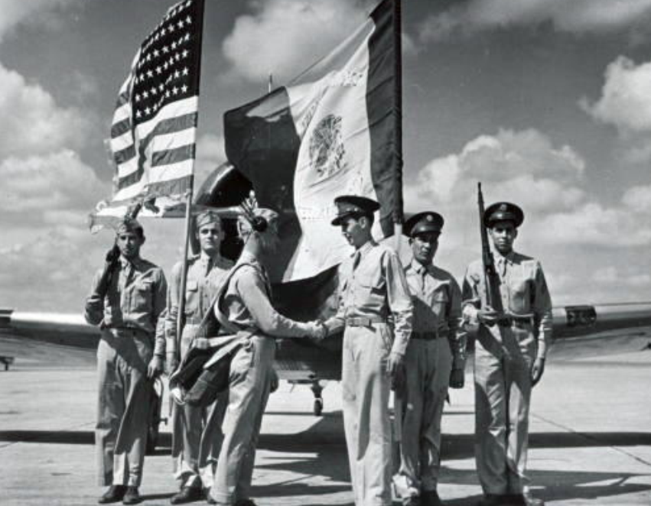
Sample image for front of dedication ceremony program
Image from: (Name of repository or collection)

OFFICIAL TEXAS HISTORICAL MARKER DEDICATION CEREMONY FOR
NAME OF SUBJECT

Presented by the Texas Historical Commission,
Post Oak County Historical Commission and
(local sponsor(s))
(Marker funded by sponsor’s name)

