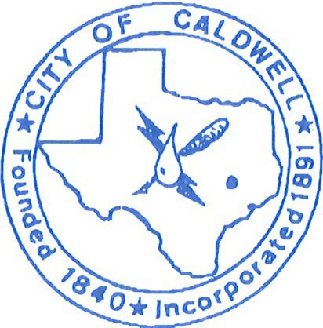
CITY OF CALDWELL
I 07 S. Hill St., Caldwell, Texas 77836
(P) (979) 567-3271 (F) (979) 567 -9233

Community Development Director

Description
………………………………………………………………………………………………………………
The City of Caldwell is located about 25 miles west of the Bryan College Station area. We are about an hour from Austin and about 90 miles from Houston. With so much going on in this part of Texas, we are primed for takeoff. The City of Caldwell is looking for a Community Development Director to help pull all of the great things in our town together making the most of the assets we have while developing a plan to create more. The Community Development Director will report directly to the City Administrator and be responsible for oversight of the Main Street Program. Caldwell is an officially designated Texas Main Street Community. The position will also oversee the Caldwell Civic Center and Museum as well as the Harrie P. Woodson Library. The position will be tasked with developing and maintaining a long-term plan for the revitalization of the downtown area as well as increasing interest and programs with the Civic Center and Library. This position is perfect for people with a passion for improving community through engagement and creative thinking.

Essential Functions
………………………………………………………………………………………………………………
- Manage all Main Street program projects.
  - Work with the Texas Main Street office at the Texas Historical Commission to develop and maintain a long-term revitalization vision for the Main Street area, and utilizing strategic planning tools, implement the vision and goals for the program.
  - Coordinate and assist Main Street Advisory Board with development and implementation of annual action plan, projects and activities.
  - Coordinate on-going public relations and education programs related to Main Street.
  - Develop and maintain productive, cooperative relationships at all levels to facilitate Main Street strategic goals.
- Oversight of Civic Center and Museum
  - Plan, organize, and direct the operations of the Civic Center and Museum
  - Develop and maintain marketing strategy to increase rental of the Civic Center
  - Maintain and evaluate rental records
  - Develop and maintain maintenance and upgrade strategies
- Oversight of Harrie P. Woodson Library
  - Plan, organize, coordinate, and direct the operations of the City library system
  - Set vision for library, and utilizing strategic planning tools, implements the vision and goals for the organization.

Requirements
…………………………………………………………………………………………………………….
- Bachelor’s degree in Planning/Community Development, Architecture, Historic Preservation, Business Administration, Marketing or a related field.
- Ability to understand the issues involved in local tourism and revitalization from the various points of view of merchants, public agencies, property owners and community organizations.
- Ability to effectively communicate program goals in group situations as well as one on one.
- Ability to maintain the highest standard of ethical behavior, exercising honesty and integrity, respect, confidentiality, and fairness in the execution of responsibilities.

