Federal Designations
Historic Resource Designation
Preservation Bootcamp

At the federal level there are two types of designations, the more common designation being the National Register of Historic Places (NRHP) as well as the National Historic Landmark (NHL), which is less common and harder to receive. The National Register of Historic Places designation program is administered by the State Historic Preservation Office (SHPO), which in Texas is the Texas Historical Commission (THC) in accordance with the NPS rules and regulations. Properties can be listed both individually and within districts. One primary distinction between NRHP designation and others is that this type is primarily an honorary designation, it is a recognition of a property’s significance. It does not come with protection or restrictions that limit what a homeowner can do with their property. A primary reason for a NRHP listing is that it can qualify a building for CLG grants or the federal and state rehabilitation tax credit, and is reviewed in the event of Sec 106 review.

National Historic Landmark (NHL) properties are nationally significant and have exceptional value in representing or illustrating an important theme in the history of the United States. NHLs can be buildings, sites, structures, objects, or district and must be evaluated by the NPS National Historic Landmark Survey. Since this designation is so exceptional, few properties carry this designation, with less than 50 of them located in Texas.

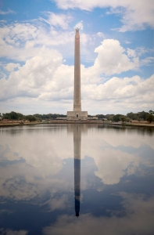
San Jacinto Battleground, NRHP, SAL, NHL

State Designations

Moving onto the state level, there are two designation types that are managed by the THC, Recorded Texas Historic Landmarks (RTHL) and State Antiquities Landamrks (SAL). Under the same idea as NRHP properties, are RTHLs, but there are some distinct differences that separate these nomonations. Only individual buildings, not districts, can be nominated as a RTHL and owner consent is required to nominate a property. Once a property has been designated, the THC reviews exterior alterations and demolition requests; interiors are left unregulated.

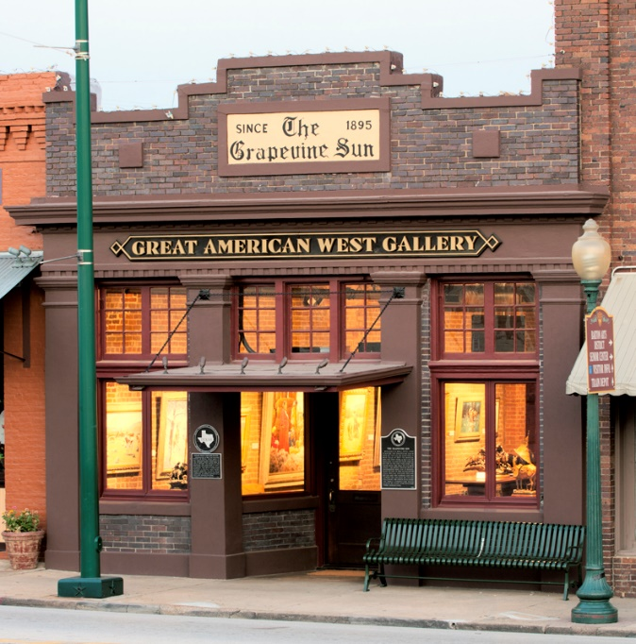
Tarrant County State Bank Building, RTHL

Similar to RTHLs, State Antiquities Landmarks are individual buildings or sites and not districts. Eligible properties are cultural resources on non-federal public lands, NRHP listed properties, and archeological sites. Once designated, these properties are protected under the Antiquities Code of Texas and they require THC review for exterior alterations and demoliton permits.

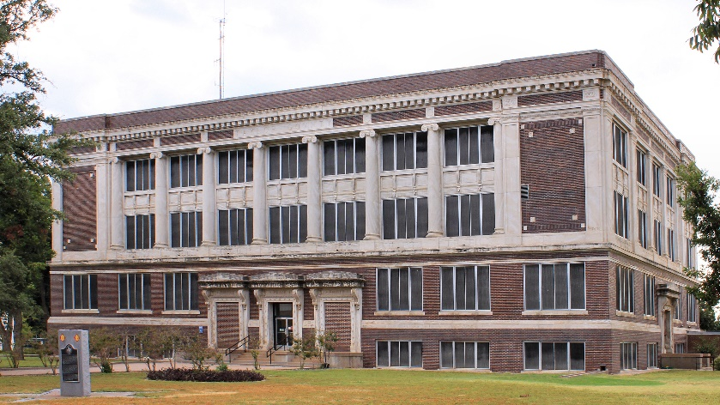
1915 Taylor County Courthouse, NRHP, SAL

Local Designations

Finally, at the local level cities, while working with their constituents, enforce legislation that allows for the designation of individual properties and districts. This type of designation is similar to the National Register of Historic Properties, but is separate in that once protected, any exterior changes or demolition must be approved by the city. These programs vary in each community, but they are all regulated by the cities’ historic preservation ordinance.

Wanting to look at some additional resources? We have a section under our CLG page with some handouts about designation and a video.

