Funding for Building Rehabilitation and Restoration

Grants
Preservation Funding
Preservation Bootcamp
During the first years after passage of the Historic Preservation Act of 1966, Federal funding for restoration grants was available. However, in 1981 Congress abandoned the grant approach in favor of an expanded Federal Historic Preservation Tax Incentives program. As a result, funds directly targeted toward brick and mortar restoration of historic buildings has largely disappeared. However, the National Park Service’s State, Tribal, Local, Plans & Grants Division (STLPG) has several grants available. The Texas Historical Commission administers these grants and several other grant and incentive programs for historic buildings.

Federal & State Historic Rehabilitation Tax Credit
Income-producing properties listed on the National Register (individual or district) or designated as a Registered Texas Historic Landmark or State Antiquities Landmark may be eligible for one or both of the tax credits programs offered through the state. The work undertaken as part of the project must meet the Secretary of the Interior’s Standards for Rehabilitation.

State Historic Tax Credit Program

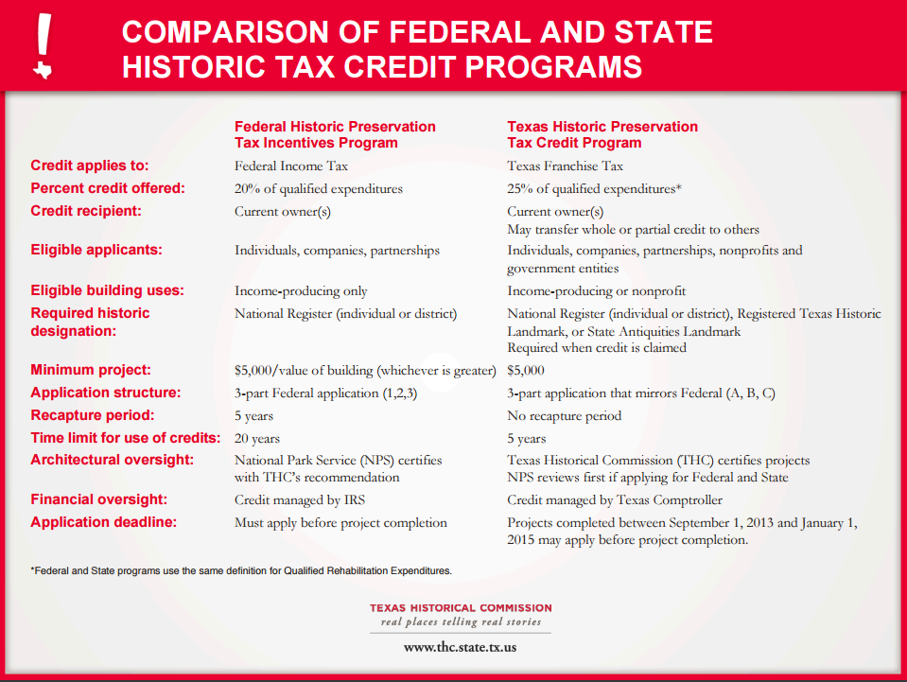

Texas Preservation Trust Fund (TPTF)
The Texas Historical Commission awards grants for preservation projects from the Texas Preservation Trust Fund. Created by the Texas Legislature in 1989, the TPTF is an interest-earning pool of public and private monies. The earned interest and designated gifts are distributed as matching grants to qualified applicants for acquisition, survey, restoration, preservation, planning, and heritage education activities leading to the preservation of historic properties and archeological sites. Competitive grants are awarded on a one-to-one match basis and are paid as reimbursement of eligible expenses incurred during the project.

The TPTF Grant Program has a two-step application process:
- All applicants are required to submit a brief application form to the THC for review. The THC will select the highest-priority projects from the initial applications and invite those applicants to move forward to the second step.
- Successful applicants will continue the process by submitting detailed project proposals.

Certified Local Government (CLG) Grants
CLG grants provide funding to participating city and county governments to develop and sustain an effective local preservation program critical to preserving local historic resources. Activities eligible for CLG grant funding must be tied to the statewide comprehensive preservation planning process. A copy of the Texas Historical Commission Statewide Preservation Plan can be found on our web site.
Priority for funding shall be given to those projects that directly relate to the following work categories:
- Architectural, historical, archeological surveys/inventories and oral histories
- Preparation of nominations to the National Register of Historic Places (NRHP)
- Preparation of a local preservation plan
- Writing or amending preservation ordinance
- Development of local design guidelines
- Research and development of local preservation incentive program
- Travel/training expenses for hosting a regional preservation-related workshop

The above list should not dissuade an applicant from applying for assistance towards other eligible projects such as:
- Research and development of historic context information
- Development of educational publications and activities, slide shows, videos, web sites, etc.
- Publication of historic context information
- Development of publication of walking/driving tours
- Development of architectural drawings and specifications
- Preparation of facade studies or condition assessments
- Projects may be prepared by consultants or developed with in-house expertise
- Rehabilitation of properties individually listed in the NRHP or contributing to a district
- Travel/training expenses for individual commission members and staff.
Because the THC is required to distribute CLG funds among the maximum number of eligible local jurisdictions, please note that individual travel/training grant requests will only be considered under exceptional or unusual circumstances.

All CLG grants require a local cash match budgeted on a one-to-one (dollar for dollar) match equal to a 50-50 ratio for the total cost of the project. Proposed projects utilizing all or partial matches of verifiable in-kind services or goods may also qualify as long as the local match equals a 50-50 ratio for the total cost of the project. Only non-federal monies may be used as a match, with the exception of Community Development Block Grants.

Local Façade Grants and Tax Incentives
There are many options for funding preservation projects. As part of a designated Main Street community, the property owner has as a resource the local Main Street manager who can help you research and identify sources of additional funding. Localized financial tools can include façade grants or other direct assistance programs that come through sources such as local economic development organizations.

Finding Grants and Funds for Building & Physical Improvements

Private Buildings
- Texas Historical Commission
- National Trust for Historic Preservation

Public Buildings
- USDA Community Facilities Direct Loans and Grants
- USDA Rural Business Development Grants
- USDA Rural Community Development Initiative Grants
- Low-Income Housing Tax Credit

Accessibility
- ADA Tax Credit
Housing
- USDA Housing Preservation & Revitalization Demonstration Loans and Grants

Churches
- National Fund for Sacred Places
- Oldham Little Church Foundation

Public Spaces / Parks
- Shade Structure Grant Program

Public Art
- Mid America Arts Alliance: Artistic Innovations Grant

For Main Street programs and other district wide projects:
- THC Main Street Funding Methods: There are funding sources at the local, state and federal levels and they are outlined in the document. The list provides only brief summaries of potential funding sources, and information including eligibility requirements and application deadlines that are subject to change without notice. If the scope of work exceeds available sources of funding, the project should be phased accordingly, but these options for funding can still be utilized. Please contact possible grantors directly for more information on their programs.

