EISENHOWER BIRTHPLACE
state historic site
EDUCATOR GUIDE

Located in the heart of Denison, Eisenhower Birthplace State Historic Site showcases the home where the 34th U.S. President Dwight David “Ike” Eisenhower was born in 1890. Antique furnishings fill the modest frame house, illustrating the working class life of the Eisenhowers. The visitors center celebrates Ike with memorabilia and exhibits featuring his many accomplishments as president and war hero. A larger-than-life statue of the general, landscaped grounds and picnic tables round out the place where everything started for the first Texas-born president.

Contact Information
Eisenhower Birthplace State Historic Site
609 S. Lamar Ave.
Denison, TX 75021
Phone: 903.465.8908
Website: www.visiteisenhowerbirthplace.com

Hours and Reservations
Educational programs and tours are available Tuesday–Friday, 9 a.m.–3 p.m. and other times by appointment. Please make reservations for your school tour at least two weeks in advance by calling 903.465.8908. Please let the site know as soon as possible if your visit is delayed or cancelled.

General Admission
Admission for school group tours is $1 per student, with one free chaperone with every 10 students. Please note that we recommend a ratio of one adult chaperone to every 10 students.

Directions
Eisenhower Birthplace is located in Denison, approximately 75 miles north of Dallas.From Main Street in Denison, head south on Crockett Street to Nelson Street and travel west to Lamar Avenue.
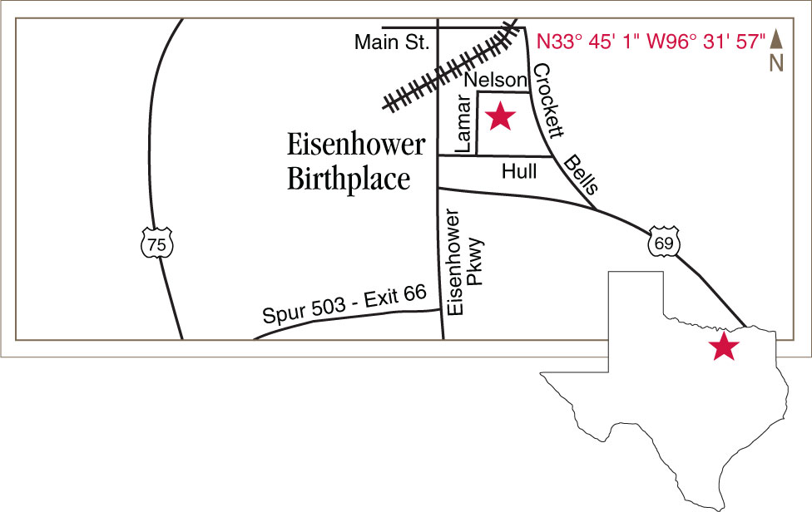
Social Studies TEKS Connections
4.4C, 4.5B, 4.18C, 4.19A, 4.19B, 4.22A
7.6A, 7.7D, 7.18A, 7.21A


