A large part of your work as a historic preservation officer will be focused on building preservation, but as previously mentioned, historic preservation encompases so much more than just the built environment. Below you will find a brief description of some other areas of preservation that you will likely encouter in your post as well as some resources to help you with them.

Archeology
Beyond the Building
Preservation Bootcamp

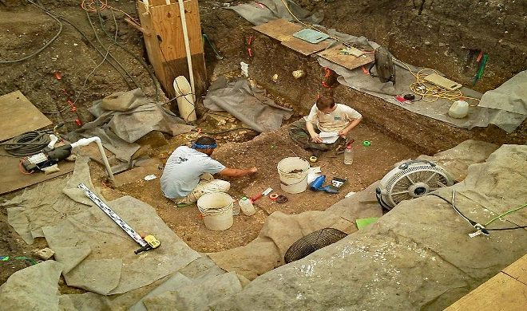
Archeology Publications & Resources https://www.thc.texas.gov/preserve/archeology/archeology-publications-resources
Texas Archeology Month – Great opportunity to host an event! https://www.thc.texas.gov/preserve/projects-and-programs/texas-archeology-month

Cemetaries

THC Preserving Historic Cemetaries
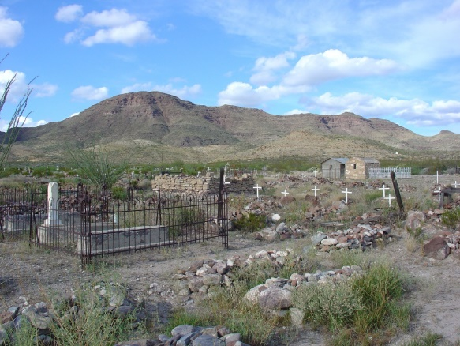
Webinar: Apply for HTC Designation http://www.thc.texas.gov/get-involved/training-consulting#cem (designations like this lead to heritage tourism)

Cultural Landscapes
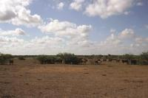

https://www.thc.texas.gov/preserve/buildings-and-property/cultural-landscapes

THC Texas Treasure Business Award

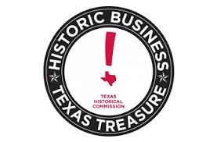
https://www.thc.texas.gov/preserve/projects-and-programs/texas-treasure-business-award

Other Resources:
Legacy Businesses from the City of San Antonio https://www.sanantonio.gov/historic/Programs/Culture/LegacyBusiness

The Texas Freedom Colonies Project
http://www.thetexasfreedomcoloniesproject.com/

NPS LGBTQ Theme Study
https://www.nps.gov/subjects/tellingallamericansstories/lgbtqthemestudy.htm

