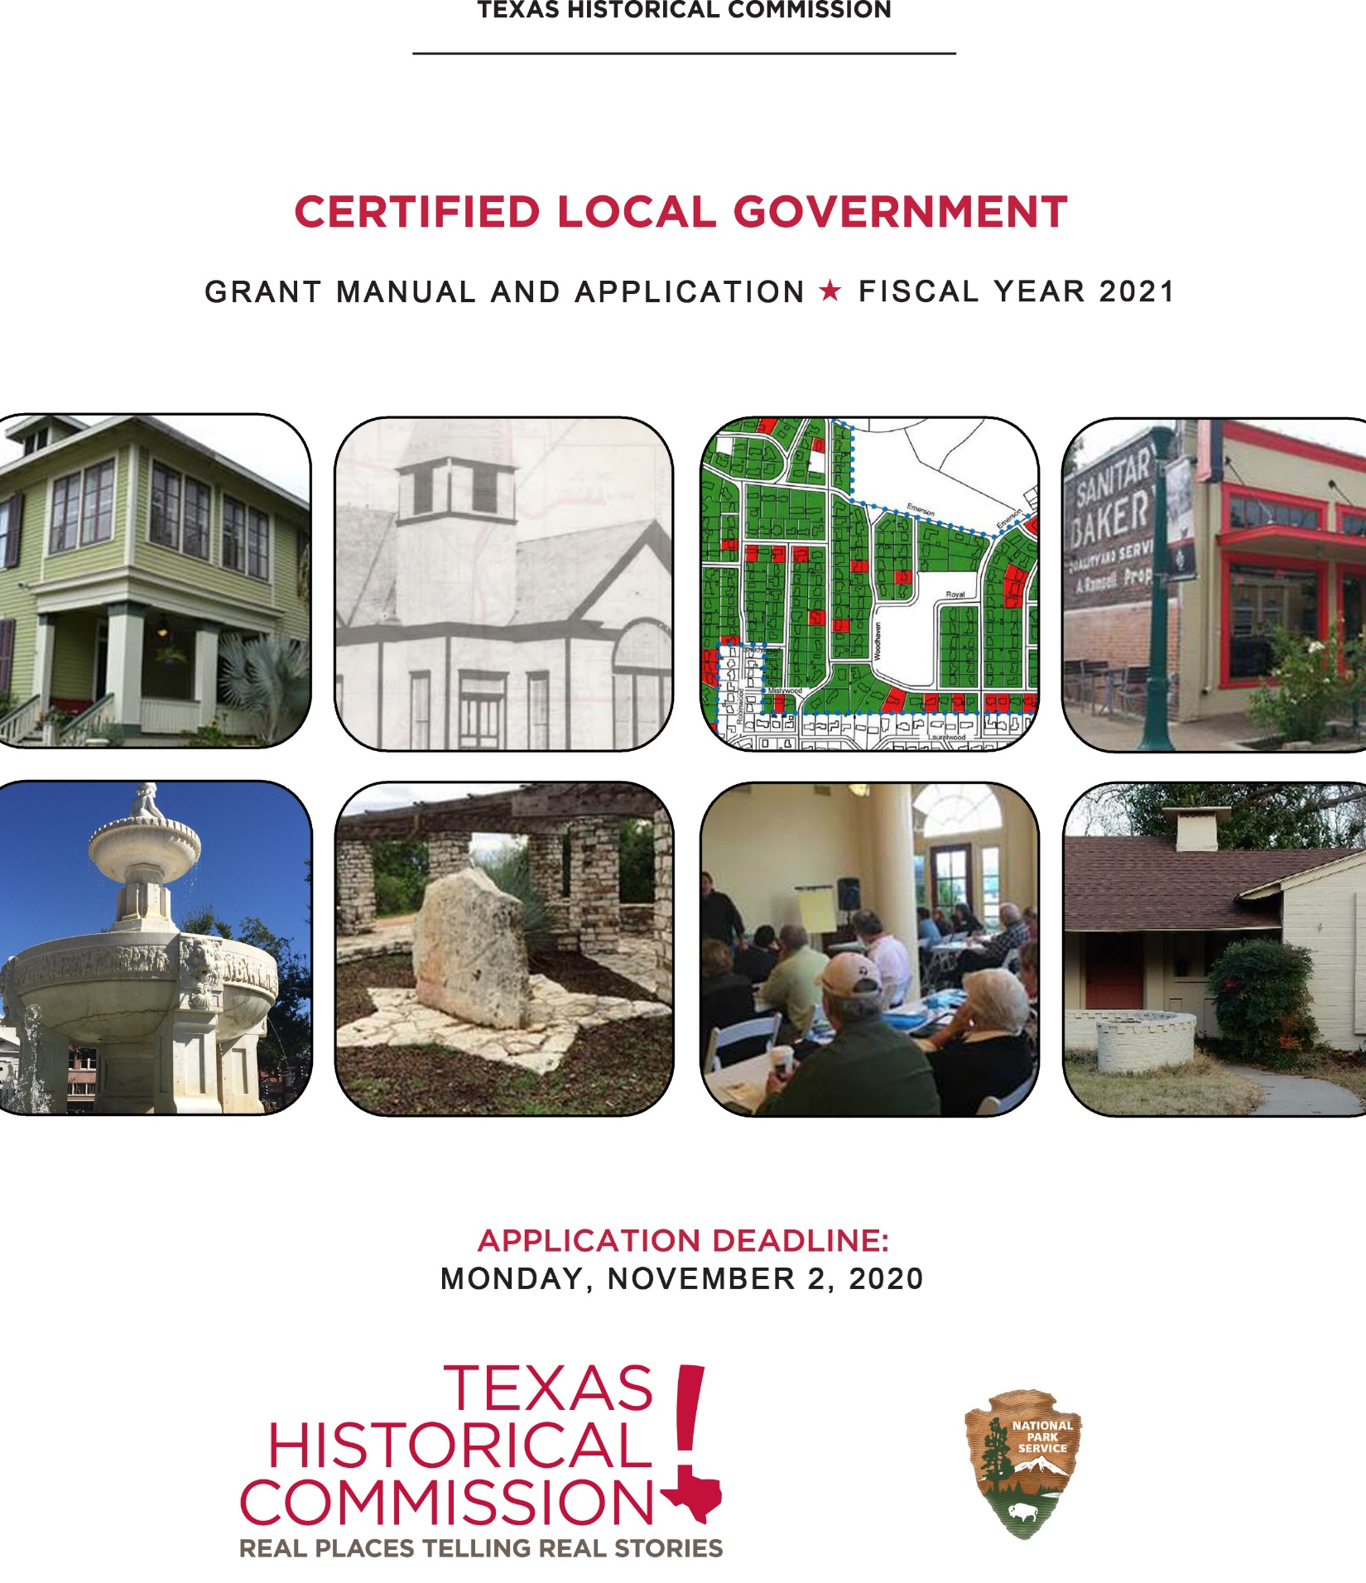

This grant manual has been financed in part with Federal funds from the National Park Service, U.S. Department of the Interior and administered by the Texas Historical Commission. However, the contents and opinions do not necessarily reflect the views or policies of the Department of the Interior.

This program receives federal financial assistance for identification and protection of historic properties. Under Title VI of the Civil Rights Act of 1964 and Section 504 of the Rehabilitation Act of 1973, and the Age Discrimination Act of 1975, as amended, the Department of the Interior prohibits discrimination on the basis of race, color, national origin, or disability or age in its federally assisted programs. If you believe you have been discriminated against in any program, activity, or facility as described above or you desire further information, please write to:

Office for Equal Opportunity
National Park Service
1849 C Street, N.W.
Washington, D.C. 20240

TEXAS HISTORICAL COMMISSION
CERTIFIED LOCAL GOVERNMENT GRANT MANUAL

CONTENTS

Introduction 3

Administrative Information 3

Who May Apply 4

Eligible Projects 4

Special Consideration for Underrepresented Communities…………………………………………5

Professional Qualifications Standards 5

Section 106 Review 5

Matching Funds Requirement 5

Grant Timeline and Responsibilities of the Grantee 6

CLG Grant Application Form 8

INTRODUCTION
Certified Local Government (CLG) grants provide funding to participating city and county governments to develop and sustain an effective local preservation program critical to preserving local historic resources. The Texas Historical Commission (THC), the state agency for historic preservation, administers the Texas CLG grant program utilizing federal funding it receives from the U.S. Department of Interior, National Park Service (NPS) Historic Preservation Fund Program. Under this program the NPS requires that at least ten percent (10%) of Texas' annual federal allocation be subgranted exclusively to participating Certified Local Governments (CLGs). The program serves as a great resource for participating county and city governments to offset the costs of self-sustaining preservation and planning-related projects. Currently, there are 76 CLGs in Texas. Contingent on resolution of the federal budget, we anticipate approximately $90,000 to $120,000 will be available for this round of grants.

administrative information
Administration Grants will be administered in accordance with the National Park Service Historic Preservation Fund Grants Manual, June 2007; Texas Administrative Code Title 13, Part 2, Chapter 15.6, Rules and Procedures for Certified Local Governments; and this manual.

Grant Period The grant period is October 1, 2020 to September 30, 2022. Project preparation, including drafting any applicable RFPs, may begin before your grant request is awarded and a grant contract signed, however, costs incurred prior to the execution of a signed contract with the THC are not eligible for reimbursement. Despite the official grant period beginning October 1st, grants will be awarded in 2021 following funding notification from the National Park Service.

Application Package The grant application form is included in this manual. A complete application submittal package consists of 1 unbound hard copy and 1 digital copy of the following documents:
- Application Form (with original signatures)
- Budget Worksheet (template is attached to the application form)
- Resume of Project Manager (City or County staff, and/or representative of the third-party organization)
- Resumes of all outside consultants, contractors, and/or individuals responsible for project oversight
  - Persons supervising grant projects must meet the Secretary of the Interior’s Professional Qualification Standards
  - If the applicant is planning to hire a consultant or subcontractor, resumes may be submitted following the selection process
- Any applicable cost estimates, maps, drawings, or photographs
- Determination of Eligibility Statement
  - Required for all National Register nomination grant requests
  - Required for all Construction/Development grant requests for properties not already listed on the National Register
  - Recommended for all Survey/Inventory projects
Visit http://www.thc.texas.gov/preserve/projects-and-programs/national-register-historic-places/request-determination-eligibility for instructions on how to request a Determination of Eligibility Statement.

Submittal Deadline A complete grant application package (hard copy and electronic) must be received no later than 5 p.m. Monday, November 2, 2020.

One electronic copy of the application must be submitted via e-mail and one printed copy must be delivered to:

HAND DELIVER OR COURIER SERVICE U.S. MAIL
Texas Historical Commission Texas Historical Commission
Community Heritage Development Division Community Heritage Development Division
ATTN: Maria Mougridis, CLG Program Specialist ATTN: Maria Mougridis, CLG Program Specialist
1304 Colorado Street PO Box 12276
Austin, Texas 78701 Austin, Texas 78711-2276

WHO MAY APPLY
Only city or county governments, and state recognized Native American Tribes that have been individually "certified" by the National Park Service before November 2, 2020 are eligible to apply for CLG grants. The THC reserves the right to disqualify applications from CLG communities that are not in compliance with the CLG Certification Agreement.

In an attempt to distribute CLG grant funds to as many CLGs as possible, preference will be given to applicants that have not received or directly benefited from CLG grant funds in the past five years.

A CLG may submit more than one grant application; however, a separate application package must be submitted for each project request.

The following entities may also be eligible:
- An organization such as a non-CLG city or another unit of local government, a commercial firm, a non-profit entity or educational institution that has administrative capabilities that comply with applicable federal standards and has been delegated as a third-party to administer the grant on behalf of the CLG. The contributed services of the third party to the CLG may be counted toward the matching share requirements of the grant. The third party may apply for the CLG grant directly, in which case, the Historic Preservation Officer or CLG Representative and the Chief Elected Official must sign the application.
ELIGIBLE PROJECTS
Activities eligible for CLG grant funding must be tied to the statewide comprehensive preservation planning process. A copy of the THC’s Statewide Preservation Plan can be found at:
http://www.thc.texas.gov/preserve/projects-and-programs/texas-statewide-preservation-plan as well as in the grant application. In an effort to encourage local governments to develop and sustain an effective local preservation program critical to preserving local historic resources, priority for funding shall be given to those projects that directly relate to the following work categories:
- Architectural, historical, archeological surveys/inventories
- Preparation of nominations to the National Register of Historic Places
- Preparation of a local preservation plan
- Writing or amending a preservation ordinance
- Development of local design guidelines
- Research and development of a local preservation incentive program

The above list should not dissuade an applicant from applying for assistance towards other eligible projects such as:

- Development of educational publications and activities, slide shows, videos, websites, etc.
- Development of publication of walking/driving tours
- Development of architectural drawings and specifications
- Preparation of facade studies or condition assessments
- Rehabilitation or restoration of properties individually listed in the National Register of Historic Places or contributing to a National Register historic district
- Training expenses for individual commission members and staff
SPECIAL CONSIDERATION FOR UNDERREPRESENTED COMMUNITIES
The CLG program is committed to enhancing undertold stories, and engaging and including a wider range of communities, perspectives, and voices in our state’s and nation’s historical narrative. To further this goal, we encourage projects from or related to communities currently underrepresented, including but not limited to Black Americans, Hispanic Americans, Asian Americans, Native Americans, Women, and LGBTQ Americans. Projects can include but are not limited to oral history projects, National Register nominations, historic resources surveys, diversity and inclusion trainings, and projects with an emphasis on cultural heritage or broader themes such as the Civil Rights movement, women’s history, and immigrant history.

Projects will be considered as part of the regular CLG grant cycle. Please reach out to program staff if you have any questions about deadlines, match requirements or project type.

PROFESSIONAL QUALIFICATIONS STANDARDS
To ensure that appropriate historical, architectural, archeological and cultural properties are identified for public benefit through grant-in-aid assistance, persons supervising grant projects must be professionally qualified in accordance with 36CFR61. The Professional Qualification Standards can be found here: https://www.nps.gov/history/local-law/arch_stnds_9.htm

SECTION 106
CLG Grants are funded with federal monies, and construction projects will require a formal Section 106 Review by the THC. This review will take place following the grant awards. Failure to obtain a review will result in forfeiture of the CLG Grant. The CLG State Coordinator will provide additional guidance once the grants are awarded. Additional information regarding Section 106 Review is available from the THC and the Advisory Council on Historic Preservation.

Matching Funds
Proposed projects are required to provide a local match for grant monies budgeted on a one-to-one (dollar for dollar) match equal to a 50-50 ratio for the total cost of the project. The local match may be any combination of cash and verifiable in-kind services. Projects may utilize all or partial match of verifiable in-kind services and/or goods as long as the local match equals a 50-50 ratio for the total cost of the project. For example, if a CLG has a project that costs $40,000 and applies for a $20,000 grant, the CLG may match $15,000 in cash, and $5,000 in staff services. It is important to note that the grant is reimbursement based, meaning the CLG will need to spend the grant amount plus the match upfront ($40,000), and be reimbursed for the grant amount ($20,000) as project milestones are achieved, or at the completion of the project.

In order to maximize the limited CLG grant funds, the THC may give preference to applications demonstrating a higher cash match. The THC reserves the right to waive the local match requirements, in full or part, at its sole discretion. The THC also reserves the right to fund grant requests in part or in full.

Only non-federal monies may be used as a match, with the exception of Community Development Block Grants. All projects shall comply with federal requirements for state and local financial responsibility as stipulated in the
Texas Administrative Code Title 13, Part 2, Chapter 15.6, Rules and Procedures for Certified Local Governments.

In extending this grant opportunity to your project, THC assumes the responsibility for ensuring that public money will be spent appropriately and with the maximum effectiveness. The THC is held accountable by the NPS for compliance with all applicable federal laws and regulations.

APPLICATION REVIEW PROCESS
Upon the receipt of applications and supporting materials, an interdisciplinary committee of agency staff will score each application based on the criteria specified on the application form. The scoring committee will make a funding recommendation to the Texas Historical Commission at the January Quarterly Meeting to fund the maximum number of projects based on the federal funding THC receives from the U.S. Department of Interior, National Park Service (NPS) Historic Preservation Fund Program. All applicants will be notified of the THC’s decision.

If two or more applicant’s scores are tied, the THC will select the applicant that has not received or directly benefitted from CLG grant funds in the past five years. If the scores are still tied, the THC will give preference to a project it can fully fund rather than partially fund.

Grant timeline AND Responsibilities of THE grantee

Summer 2020 Applications for the FY2021 CLG grant period are made available.

November 2, 2020 A signed and complete application package, including all supporting materials, must be received by the THC no later than 5 p.m. on Monday, November 2, 2020.

November 2020 Review of applications by an interdisciplinary committee of THC staff.

January 2021 Final award decisions made by the Texas Historical Commission at its Quarterly Meeting. All applicants are contacted by mail, and phone or email regarding the THC’s decision.

Feb 2021 - April 2021 THC sends preliminary notification to grant recipients that will include a request for a revised/amended project scope of work and budget. Once the scope of work and budget are agreed upon by the Grantee and THC, the grant contract will be sent to the Grantee for signatures. The contract must be signed by all parties before the commencement of project work. Failure to submit any or all of this documentation by the required deadlines may cause the requested grant monies to revert back to the THC.

The project manager, fiscal manager, and anyone else who will be significantly involved with the grant-funded project shall participate in a CLG Grant Orientation coordinated by the THC. The purpose of the orientation is to review project-specific requirements, expectations for project deliverables, important deadlines and milestones, and reimbursement procedures. The orientation requirement may be waived at the sole discretion of the THC.

The recordation of a Preservation Easement will be required for all construction and certain other projects prior to the commencement of any work. Duration of Preservation Easement will be based on award amount, see table below.

Award Amount: Duration of Easement:
Less than $10,000 10 years
$10,000 – $30,000 15 years
$30,001 – $50,000 20 years
Greater than $50,000 30 years

If the Grantee is not doing the actual work, it must execute a contract with a subcontractor. All subcontracted services and products must be procured according to Federal procurement standards set forth in Chapter 17 of the Historic Preservation Fund (HPF) Grants Manual and 2 CFR Part 200.317- 200.326. THC will review and approve all RFPs and contracts between the Grantee and subcontractor.

Work conducted, or costs incurred, prior to the execution of the contract is not eligible for reimbursement.

April 2021 - Sept 2022 THC staff routinely review projects to monitor progress and provide assistance. Each Grantee is required to provide the THC with status reports on each project funded, as requested.

The Grantee shall submit drafts of project deliverables, as available.

September 30, 2022 Deadline for the completion of all work eligible for reimbursement. Any work done after September 30, 2022 will not be eligible for reimbursement.

October 31, 2022 All final work products are due. All deliverables must be reviewed and approved by the THC and accompanied by a Completion Report before the project is considered complete.

All final reimbursement requests are due. Eligible project expenditures incurred on a one-to-one (dollar for dollar) basis up to a 50-50 ratio of the total project cost shall be reimbursed to the CLG.

CERTIFIED LOCAL GOVERNMENT SUBGRANT
FISCAL YEAR 2021 GRANT APPLICATION FORM

Deadline for submission is November 2, 2020
Please fill out this section completely and use only the space provided below.
Handwritten applications will not be accepted.

Name OF PROPOSED PROJECT:
Certified Local Government Name:
Third party name (if applicable):

CONTACT INFORMATION: |  |  | Project Manager |  |  |  |  |  | Fiscal Manager
Organization Name
Contact Person
Address
City | State | Zip
Telephone | Fax
Email
Political Contacts: |  | Historic Preservation Officer, or  CLG Representative |  |  |  |  |  |  | City Mayor or County Judge
Contact Person
Address
City | State | Zip
Telephone | Fax
Email

FUNDING REQUEST:
Grant Funds Requested: | $ | Matching  Funds: | $ | Total Project  Cost: | $

PROPOSED PROJECT TYPE (check one that applies):
Archeological Project Research & Development
Preservation Planning Project Education & Outreach
National Register Nomination(s)¹ Design Guidelines
Survey/Inventory Project
Historic Preservation Plan or Element/Chapter of Comprehensive Plan
Construction/Development Project²
Preservation Training

¹ Applications submitted without THC Determination of Eligibility will not be reviewed
² Property must be listed or deemed eligible for listing in the National Register of Historic Places
CERTIFIED LOCAL GOVERNMENT SUBGRANT

FY 2021 Grant Application Narrative Template

NAME OF PROPOSED PROJECT:

Certified Local Government Name:

Third party name (if applicable):

Applicants will be scored on each question equaling the sum of available points in that category.

Applicants will be scored on the CLG’s compliance with CLG Program Requirements. For more information about CLG Program Requirements for both Cities and Counties, visit http://www.thc.texas.gov/preserve/projects-and-programs/certified-local-government/requirements-clgs

CLG Performance (15 Points):

1. Did the CLG submit a complete FY18 Annual Report on or before the deadline. CLGs that have not completed CLG Annual Reports for the past two fiscal years will not be eligible for grant funds.

Yes No

2. Does the CLG routinely submit preservation commission or CLG committee meeting minutes to the THC?

Yes No

3. Has the HPO or CLG Representative attended at least one preservation-related training in the past year? Please list the trainings below.

Yes No

Description and Date of Training:

4. Has at least one member of the preservation commission or CLG committee attended at least one preservation-related training in the past year? Please list the trainings below.

Yes No

Description and Date of Training:

5. Has the CLG returned CLG grant funds in the past five years?

Yes, I understand that up to five points will be deducted No

- Project Summary
Provide a summary of the proposed project.

- Project Need (15 Points):

How did the CLG identify the need for this project? Has the need been documented? If so, how?

How was the project initiated? (City Council, the public, preservation commission, etc.)

How does the project address a goal of the local government’s preservation program or a specific preservation need?

- Project Objective (15 Points):

Define the objective for the proposed project.

Identify the steps the applicant and/or the consultant must take to accomplish the project objective.

What is the estimated timeframe to accomplish each of these steps?

Who will be leading the project? What qualifies this person to lead such a project? Resumes must be provided.

- Significance and Impact (16 Points):

Does the project involve a threatened or potentially threatened resource?

Will the project result in a National Register nomination or Survey/Inventory?

Does the project directly address a deficiency in the local preservation program?

How will the project reach and inform broad sectors of the public?

- Public Involvement and Benefit (13 Points):

Will the public be involved in the proposed project? How?

Does the project address or benefit an underrepresented group within the community?

How will this project enhance public and private support for local preservation?

Will this project result in educational publications or activities?

- Budget and Cost Effectiveness (15 Points):

How necessary are CLG funds in order to accomplish the proposed project?

How did the applicant develop the project’s budget? (research, past experience, etc.)

What is the applicant’s source and commitment of matching funds?

Is the proposed project the most cost effective way of addressing those needs?

ATTACHMENTS: Please include all applicable attachments to the grant application. Resumes of Project Manager and all outside consultants are required for all projects. Below is a list of possible attachments for each project type.

Survey and Inventory: Survey area boundary map, street view images, Determination of Eligibility Letter (recommended but not required)

National Register Nominations: Physical address, Boundary or location map, Determination of Eligibility Letter (required), photograph(s)

Design Guidelines: current design guidelines, outline of sections or chapters of proposed guidelines

Education and Outreach: Outline of script, draft agenda clearly defining the subject of the training

Other Projects: Please contact the CLG Program staff to discuss recommended attachments for projects not previously listed.

- STATEWIDE COMPREHENSIVE PRESERVATION PLANNING PROCESS (11 Points Total): CLG funded projects should meet at least one of the goals outlined in the THC’s Statewide Preservation Plan. Please select the Statewide Preservation Plan Goals addressed by your project and explain how they are addressed. It is not necessary for your project to address all the goals listed in the Statewide Preservation Plan.

SURVEY AND ONLINE INVENTORY: Texans undertake a comprehensive survey to document the state’s diverse historic and cultural resources resulting in a publicly accessible online inventory.

EMPHASIZE CULTURAL LANDSCAPES: Preservation practices are enhanced by emphasizing cultural landscapes.

IMPLEMENT POLICIES AND INCENTIVES: Cities, counties and the state implement preservation policies and incentives to effectively manage historic assets.

LEVERAGE ECONOMIC DEVELOPMENT TOOLS FOR PRESERVATION: Communities leverage preservation-based and traditional economic development tools to revitalize historic areas.

LEARN AND EXPERIENCE HISTORY THROUGH PLACE: Texas residents and guests learn and experience the state’s diverse history through formal education, recreation, and everyday interactions with historic places.

CONNECT PRESERVATION TO RELATED FIELDS: Preservation is connected and integrated into related fields and activities, building a broader, stronger, and more diverse community.

CULTIVATE POLITICAL COMMITMENT: Political commitment is cultivated for historic preservation.

BUILD CAPACITY OF PRESERVATION COMMUNITY: The existing preservation community develops its capacity to function more effectively and efficiently.

Please summarize how your project addresses the goals selected above:

ACKNOWLEDGEMENTS - By checking below the applicant acknowledges:

One electronic copy of this request must be received via email by the Texas Historical Commission no later than 5 p.m. on Monday, November 2, 2020 in order to be considered.

One signed hard copy of this request must be received (hand delivered, US Mail, UPS, FedEx, etc) by the Texas Historical Commission no later than 5 p.m. on Monday, November 2, 2020 in order to be considered.

Consideration for funding is based on the demonstrated need, a compelling explanation of how the expanded project scope of work will benefit the CLG, and the applicant’s ability to match the funds being requested.

Commencement of grant-funded work may not begin prior to receipt of a signed grant contract between the THC and the grantee, and participation in a grant orientation meeting.

Verified by the signature below, the chief elected official of the CLG is aware of this application and supports the proposed project.
For requests involving construction projects, the property owner will be required to file a preservation easement for the property that will run with the land for a specific period of time based upon the amount of the final grant award.

The applicant hereby acknowledges that the information provided on this application is accurate to the best of their knowledge.

Applicant’s Certification:

Signature: ___________________________ Title: ______________________ Date: ______________

historic preservation officer or CLG representative’s Certification: Only applicable if the “applicant” is a third party designee.

Signature: ___________________________ Title: ______________________ Date: ______________

Chief Elected official Certification: Application must be signed by the chief elected official of the CLG (e.g. Mayor or Judge) or chief administrative official (e.g. City Manager).

Signature: ___________________________ Title: ______________________ Date: ______________

CERTIFIED LOCAL GOVERNMENT SUBGRANT

FY 2021 Grant Budget Worksheet

NAME OF PROPOSED PROJECT:

Certified Local Government Name:

Third party name (if applicable):

BUDGET  ITEM | GRANT  FUNDS | LOCAL  CASH (source) | LOCAL  IN-KIND (source) | TOTAL  COSTS
TOTALS

Please complete the attached budget form and provide any supplemental information necessary to confirm or support the issues described above.

Proposed projects can use a local cash match for grant monies budgeted on a one-to-one (dollar for dollar) match equal to a 50-50 ratio for the total cost of the project. Proposed projects utilizing all or partial match of verifiable in-kind services and/or goods may also qualify as long as the local match equals a 50-50 ratio for the total cost of the project. The Texas Historical Commission (THC) reserves the right to fund grant requests in part or in full based on the review criteria outlined in the application form, and the amount of federal funding available. Final decisions will also take into consideration the annual performance of each CLG applying for assistance. Only non-federal monies may be used as a match, with the exception of Community Development Block Grants (CDBG).

DEADLINE FOR RECEIPT OF APPLICATIONS IS
Monday, November 2, 2020 by 5 p.m.

PRINTED APPLICATIONS (REQUIRED)MUST BE RECEIVED AT
Certified Local Government Program
Texas Historical Commission

P.O. Box 12276
Austin, Texas 78711-2276
(Physical Address: 1304 Colorado Street, Austin, Texas 78701)

ELECTRONIC APPLICATIONS (REQUIRED) MUST BE RECEIVED AT

Maria Mougridis, CLG Program Specialist
Maria.Mougridis@thc.texas.gov

-or-

Lorelei Willett, CLG Program Coordinator
Lorelei.Willett@thc.texas.gov

- One electronic copy of this request must be received via email by the Texas Historical Commission no later than 5 p.m. on Monday, November 2, 2020 in order to be considered.
AND
- One signed hard copy of this request must be received (hand delivered, US Mail, UPS, FedEx, etc.) by the Texas Historical Commission no later than 5 p.m. on Monday, November 2, 2020 in order to be considered.

- Late applications will not be accepted

- Faxed applications will not be accepted

- Handwritten applications will not be accepted

