The Mystery of the Caddo Mounds in Coppell, Texas

In May 2015, the Coppell Historical Society invited regional archeologists Jeff Durst and Becky Shelton from the Texas Historical Commission to participate in their research and investigations of the “Caddo Mounds” as described through family histories passed down from early settlers in the Grapevine and Coppell area. Members of the Coppell Historical Society had conducted extensive archival and map research which provided a good background from the local literature and these resources were integrated into this study.

Who are the Caddo?
In order to provide a historical context, a brief overview of archival and archeological research is summarized below. The Caddo Nation was formed through alliances of tribes that shared customs and had similar languages. Their ancestral home is the territory that encompasses East Texas, northwestern Louisiana, western Arkansas, and southeastern Oklahoma (Figure 1). Their origins are steeped in this region, and their modern day tribal headquarters are in Binger, Oklahoma. Historically, the name “Caddo” (which is derived from the French abbreviation Kadohadacho, a word meaning “real chief”) was not utilized or significant until the people were moved to Indian Territory in the late 1800s. Prior to then, the Caddo was one of at least 25 distinct social entities known in the ethnographic record (Perttula 1992:6).
For thousands of years, Native American tribes in the south and southeast were relatively mobile groups, hunting game and gathering wild foods. But around 1,200 years ago (800 AD) the prehistoric Caddo had settled in and “were horticulturalists, traders, [who] lived in hamlets and villages along well watered springs, and built temples and burial mounds to mark the ceremonial and religious places sacred to important priests and chiefs” (Perttula 2004:370). The Teran de Rios map that was illustrated in 1691-1692 of the Upper Nasoni village presents a bird’s eye view of these hamlets and villages. Upon settling in, they began to build mounds around 800 AD (Figure 2). The mounds were usually placed in the center of “civic-ceremonial centers” and in addition to use as temples and burial mounds; they were places for ceremonial fires (Perttula 1992:13) and even used to track the constellations (Richard 2014).
The Caddo tell their origin story-- they emerged and came out of the earth, “from the mouth of a cave in a hill” at a location near what we know of today as the junction with the Red River and the Mississippi (Perttula 1992). From here they spread west along the Red River.
The development of the distinct regional [Caddo] culture was based on their complex social and political system of authority, ritual and ceremony (Perttula 1992:13). The mound building culture reached its height around 1500 AD (Perttula 2004:394), and the earthen mounds were no longer constructed after 1700 AD (Perttula 1992:17). The westernmost Caddo mound sites recorded are seen in Harry Shafer’s map of recorded mound sites in Texas (Figure 3) (Shafer 2006:3).
The civic-ceremonial mound complexes were built along the major and minor streams of the Trans-Mississippi South- the Red, Arkansas, Little, and Ouachita Rivers (Perttula 1992:13), the Sabine River and Big Cypress Creek. Some of these mounds are still visible on the landscape today, with one of the southwestern most being preserved and open to visitors at the George C. Davis site, Caddo Mounds State Historic Site in Alto, Texas, which is 25 miles west of Nacogdoches (Figure 4). The method they used was relatively simple, but extremely labor intensive. They would mine the soft loamy soil in the river bottoms, fill baskets, and deposit the soil into the mounds, building it and shaping primarily by hand. There are borrow pits near some of the remaining mounds where the soil was originally taken from. The amount of man-power that it took to build these mounds was extensive, and would require large, well organized groups to construct.
Westward excursions by members of Caddo tribes could have occurred between 800-1300 AD, possibly prompted by buffalo hunts into the plains. Recent research was conducted by archeologists comparing technological styles of manufacture for ceramics, arrow points, and deer bone “beamers” (which were used for deer hide preparation) from the George C. Davis site. This research has tied the material culture of the northern Prairie Caddo (Figure 5) closer to the Caddo cultures of east Texas than the Central Texas cultures (Shafer 2006:1). Despite these connections, material culture similarities are confined to the ceramics and stone tools, with no evidence of mounds being built in the upper Trinity River basin, specifically in Tarrant or Dallas counties. On Mountain Creek, west of Fort Worth, a Caddo era hamlet (1200-1300 AD) was recorded during the investigations preceding the development of Joe Pool Lake. Ceramics, diagnostic arrow points and post molds indicative of round houses were found, but there was no evidence that mound building would have occurred. In addition, campsites with Caddo-like ceramics have been recorded along Village Creek, which is near modern day Arlington.
Why were mounds not constructed this far west? As horticulturalists, the Caddo farmed the soft, sandy loam soils of the Piney Woods in east Texas with their stone and bone tools. The rich soils of the Blackland Prairie in north Central Texas were impenetrable to stone and bone tools, and the clays can only be farmed with mechanized equipment (Figure 6).
Larry Banks, an archeologist and stone tool resource specialist, (1978) has noted that there was a gap of occupation, almost a complete abandonment, in the north central Texas region, including Tarrant County. He states that there was 200-250 years between the last sedentary, native people, and the white settlers (1978:13). This scarcity of occupation between 1600-1800 AD has been noted by other prominent regional archaeologist (Skinner 1988).
In Coppell, upon examination of the topographic maps; it appears that the “mounds” were located at the edge of a natural uplift, and the mounds are actually part of a narrow ridge that looks like a series of pronounced hills on the west side of the floodplain. (Figure 7). Yet it is this type of landform that was a preferred campsite for ancient hunters and nomadic tribes.
There have been numerous prehistoric sites recorded along the Elm Fork of the Trinity River. Specifically, there was a prehistoric site along Old Ledbetter Road recorded in 1971 before the major construction events occurred in the area, very near, or possibly at the location of the supposed “Caddo Mounds”. The site form on file at the University of Texas-Austin, Texas Archeological Research Laboratory, provides some clues to the nature of the landscape before construction and the complete remodeling of the area. Nicknamed the Trench Silos site (41DL234), it contained stone tools associated with an Archaic occupation, which probably have occurred almost 6,000 years ago (Figure 8). The site files note the location is on a base of a hill near an old meander scar of Grapevine Creek. The site contained a deeply buried shell midden that had been exposed in some trench walls. There were stone tools and lithic debris, as well as bone present. From the description, this was a campsite with evidence of hearths, ash, and burned rock.
When Larry Banks was interviewed for a newspaper article (Pettit 1995), he also referenced these stone tools, or points, from the Trench Silos site as from the Archaic period. These types of hunting tools predate the development of the ceremonial mound complexes, and are affiliated with more nomadic hunters of big game, such as buffalo, elk and deer. Large campsites recorded in the upper Trinity River basin are not associated with the sedentary horticulturalists, but they provide evidence of camping and food processing, of groups of people who were returned to the rivers seasonally.
In a review of historical accounts, early references to the Caddo note numerous instances of explorers and trappers encountering them in east Texas, Louisiana, and Arkansas (Swanton 1996 [1942]).
- De Soto’s expedition – 1542 – chronicles the meeting of the members of the entrada with “successful maize agriculturalist and bison hunters”. These groups were southern Caddoan-speaking groups living between the Arkansas and Red River valleys, and south into deep East Texas (Perttula 1992).
- 1650 -Southern Plains tribes’ spoke of the “Kingdom of Tejas”, which were the southern Caddoan-speaking groups poised between the French and the Spanish territories.
- 1680-1690 - Multiple trips of friars were recorded of ventures into East Texas to attempt to establish missions in Kahadacho/Caddo territory (Swanton 1996 [1942]:46).
- Numerous accounts of the French and Spanish visiting, trading and negotiating with the tribes on the Red River from 1717 to the 1770s.
- After the Louisiana Purchase in 1803, the Caddo territory of East Texas became of significant interest to the United States.
- In a series of political moves, their territory was systematically encroached upon. By 1835 at the Caddo Agency in the State of Louisiana, they relinquished all their territory in the United States and the Caddo were moving westward and settled temporarily around Caddo Lake in East Texas.

Why were the Caddo in Tarrant County?
The Caddo remained in parts of north-eastern Texas until as late as 1842, where they cooperated, lived, and interacted with the European and American colonizers of their land until they were removed first to the Brazos River valley in the 1840s and 1850s, some going as far as the Trinity River valley, then on Oklahoma in 1859 (Perttula 2004:370).
Following the tradition of forming alliances, many of the tribes had begun to camp together during the relentless drive westward from the onset of settlers, and that is what we see happening in the 1840s in the Trinity River area near Fort Worth. The Caddo, Anadarko, and Hainai were present at the signing of the treaty at Bird’s Fort September 29, 1843 (Swanton 1996). This meeting was originally planned to be held at Grapevine Springs, but not all parties showed.
The lore of Caddo mounds being constructed by the Caddo goes deep into early settler history, and has perpetuated to this day. This happens often and occurs when family stories tell of Indian mounds on their property, then stories are passed down, and eventually become part of local history. Following are some of the examples that we were able to read about for the Dallas/Fort Worth area.

Early settler accounts:
- From an except “Of Railroads, Indians, Bandits & Gun Molls” early settlers in the Dallas area – 1843, John Neely Bryant, persuaded the Caddo and Cherokee tribes to withdraw from the land on which he wished to settle (Masterson 1988).
- 1878 – Bennett family moved to Coppell – reference to the Caddo in the Grapevine Springs area from 800-1500 based on arrowheads? No other sources presented (Vesey 1986). It more likely that they found large dart points such as those found at the Trench Silo site.
- 1897 – The Crow family moved near a series of hills known as the Caddo Mounds “legend has it that the tribe of Caddo Indians once roved and hunted the prairies for buffalo and prairie chickens and named the mounds and a small lake” (Boles 1977).
- 1914-1980 – the farmland between Carrollton and Coppell was the home of the Ledbetter family for four generations. It was bordered on the north and west by the snake-like “Caddo Mounds” (Graham 1990).
- Bethel Community – 1916 – Mr. and Mrs. E.E. Ledbetter moved from Ellis County to a 200-acre farm about four miles west of Carrollton, on the south side of a railroad “of what the Indians called “Caddo Mounds” (Ledbetter and Graham n.d.).

Once this misnomer began to appear in the printed literature, it is easy to see how incorrect citing and references were perpetuated (see Pettit 1995, Jones 1999, Alaniz 2001). Fast forward to the 21st century, and the misnomer continues into recent news stories.

- In a 2001 newspaper article “Arrowhead Collection returns to city as a gift”, Veronica Alaniz in mis-quotes Larry Banks newspaper article from 1995 when she states “the arrowheads….found in the same area are believed to date from the Caddoan Period and may be almost 7,000 years old.” – Correction: the Caddo were not the politically organized culture at that time, nor were they building mounds that long ago.
- Jo Virgil in his newspaper article “City is many communities rolled into one” states that in the area before the settlers arrived in the area known now as Irving, “the Comanche, Delaware and Caddo Indians often crossed the area’s river bottoms, prairies and wooded hills”. This area was later known as California Crossing on the Elm Fork of the Trinity River. True: Early reports of the construction of Fort Worth mention Indian encampments along the Trinity River (Perkins 2001:8), between 1839-1840. Settlers came into Irving in 1844 after Bird Fort was established.

If the Caddo were camped along the Elm Fork of the Trinity River in the early 1800s, it would make sense that they would camp on high ground above the floodplain with close access to the waterway, hence the name “Caddo Mounds” being associated with the hills. The Crow and Ledbetter family histories support this association from their early accounts.
Were there ever mounds built in the floodplain of the Elm Fork of the Trinity River by the Caddo? Probably not. It is outside of their ancestral area, and mounds were built in very different soils in very different settings. The historic and archival records are clear that the Caddo arrived in the Coppell area in the mid-1800s. The building of mounds had ceased by the 1700s. Therefore we suggest that they were not mounds, but geological formations such as the “sinuous” hills at the edge of the Trinity River floodplain that had been utilized as campsites by Native Americans as far back as 6,000 years ago (Figure 9). By retracing the printed and oral histories, it is understandable why the association has been made, and then passed down. This is not unusual that oral histories and stories passed down can be exaggerated or elaborated from actual events. What is intriguing is the extent of prehistoric occupation in the region, and throughout Texas, and what we can learn from this kind interest that this research has generated.

SOURCES CITED

Alaniz, Veronica
2001 Arrowhead Collection returns to city as a gift. Dallas Morning News: Northeast Tarrant County. Saturday, January 13, 2001, Section 1N.Banks, Larry
1978 Archeology. In Grapevine Area History. Charles H. Young, editor, pp. 10-13. Grapevine Historical Society, Taylor Publishing Co., Dallas.
Boles, Bertha Crow
1977 A Return to the Past: Crow Family History.
Graham, Bernice Ledbetter
1990 Ledbetter Farm. Elm Fork Echos, April 1990.
Jones, Anthony
1999 The White Rocker. Indian Predecessors occupied the Lake area more than 3500 years ago. Thursday, February 18, 1999.
Ledbetter, Buren and Bernice Ledbetter Graham
n.d. Bethel Community.
Masterson, V.V.
1988 The Katy Railroad and the Last Frontier. University of Missouri.
Murph, David
2013 Founders of Fort Worth, From the Old Frontier to the New. In Never Without Honor: Studies of Courage in Tribute to Ben H. Procter. Stephen F. Austin University Press.
Perttula, Timothy K.
1992 “The Caddo Nation” Archeological and Ethnohistoric Perspectives. University of Texas Press, Austin.
2004 The Prehistoric and Caddoan Archeology of the Northeastern Texas Pineywoods. In The Prehistory of Texas. Edited by Timothy K. Perttula, pp. 370-408. Texas A&M Press.
Perkins, Clay M.D.
2001 The Fort in Fort Worth. Cross Timbers Heritage Publishing Company, Keller.
Peter, Duane E. and Daniel E. McGregor
1988 Late Holocene Prehistory of the Mountain Creek Drainage. Archeology Research Program, Southern Methodist University.
Pettit, Amy
1995 The Grapevine. Area’s History goes way back. Archeologist: Ancient society calls Grapevine home. Sunday, November 4, 1995.
Richard, Mark A.
2014 The George C. Davis Mound Site: A Celestially-Oriented Site Lacking Multi-Mound Solar Alignments. Paper presented at the Joint 56th Caddo Conference and 21st East Texas Archeological Conference, Tyler, Texas.
Texas Beyond History
n.d. Mounds of Mystery. http://www.texasbeyondhistory.net/kids/caddo/mounds.html
Shafer, Harry J.
2006 People of the Prairie: A Possible Connection to the Davis Caddo Site. Texas Department of Transportation, Environmental Affairs Division and Prewitt and Associates, Inc., Cultural Resources Services.
Skinner, S. Alan
1988 Where Did All the Indians Go? The Record 42(3):101-104.
Swanton, John R.
1996 [1942] Source Material on the History and Ethnology of the Caddo Indians. University of Oklahoma Press, Norman.
USGS
1925 Dallas 2-b Quadrangle, published as Carrollton partial 15’ quad.
1959 Carrollton, Texas 7.5’ USGS quadrangle.
Virgil, Jo
DATE City is many communities rolled into one. Fort Worth Star Telegram DATE.
Texas Archeological Site Atlas
2014 Accessed to determine sites recorded on Carrollton 7.5’ USGS map.
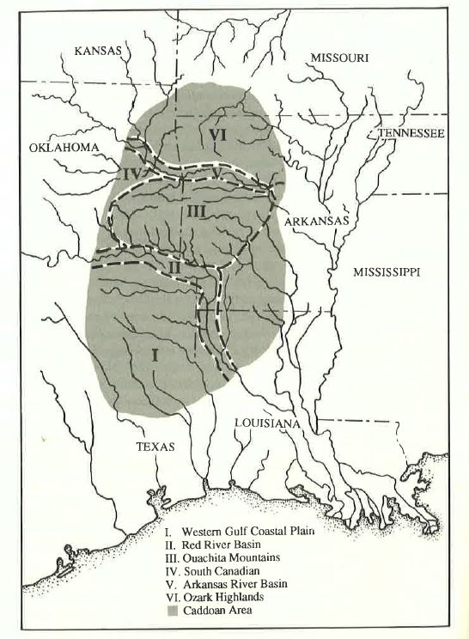
Figure 1. The Caddoan Archeological Area – Perttula Figure 13.1 – or Figure 1 (Perttula 1992).

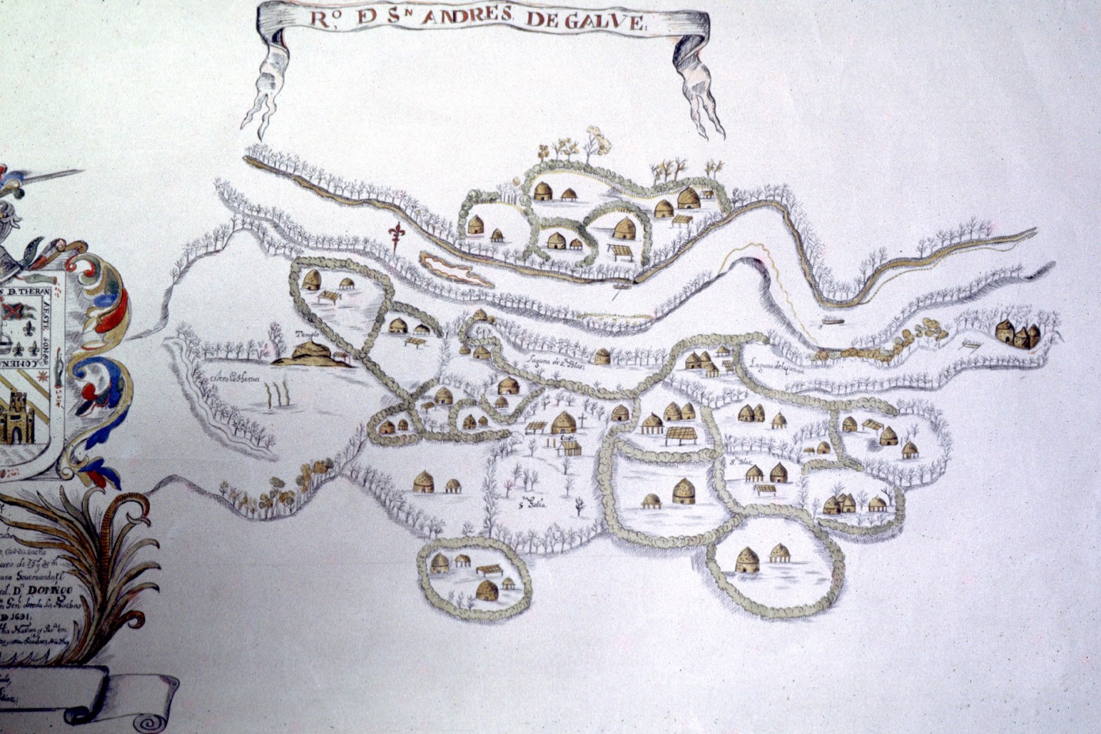
Figure 2. Teran Map of illustrated Nasoni village.

Figure 3. Map of mound sites in east Texas, adapted from Perttula 2004:386.

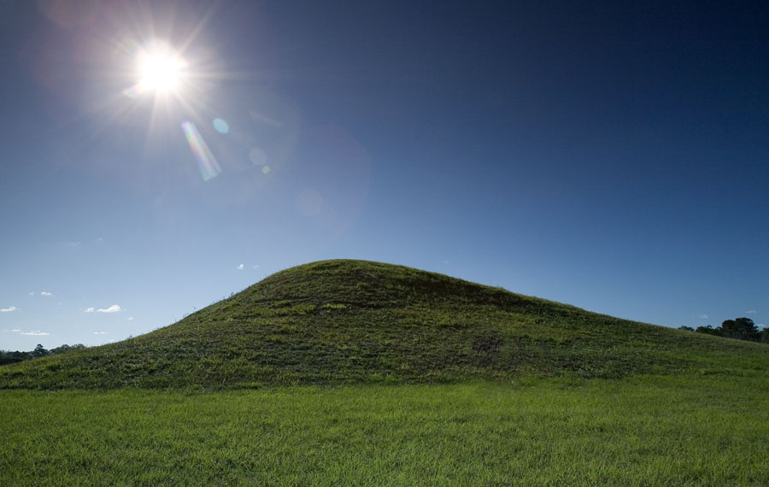

Figure 4. Caddo Mounds State Historic Site

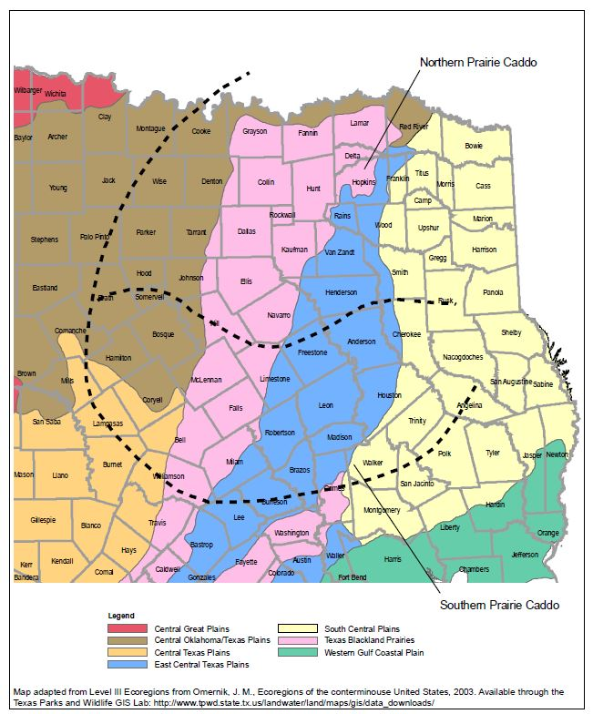
Figure 5. The approximate geographic area proposed for the Prairie Caddo superimposed over ecoregions of central and east Texas (Shafer 2006: Figure 1).

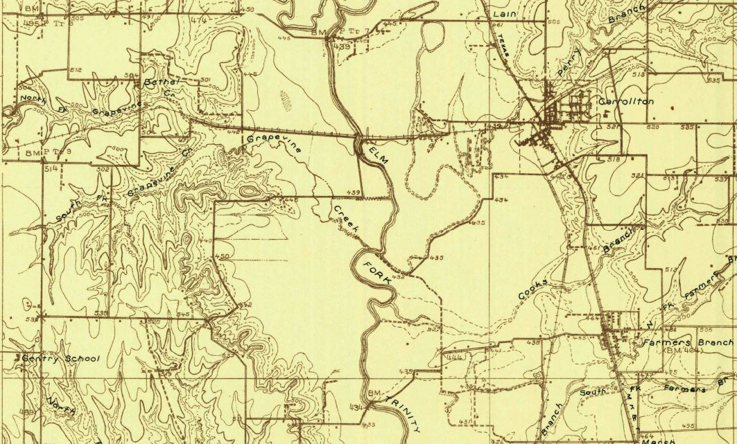
Figure 6. 1925 USGS topographic map – before lake construction.

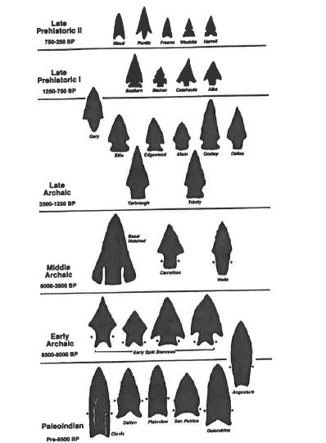
Figure 7. North Central Texas point typology – Prikryl 1990 (Figure 24) Texas Historical Commission.

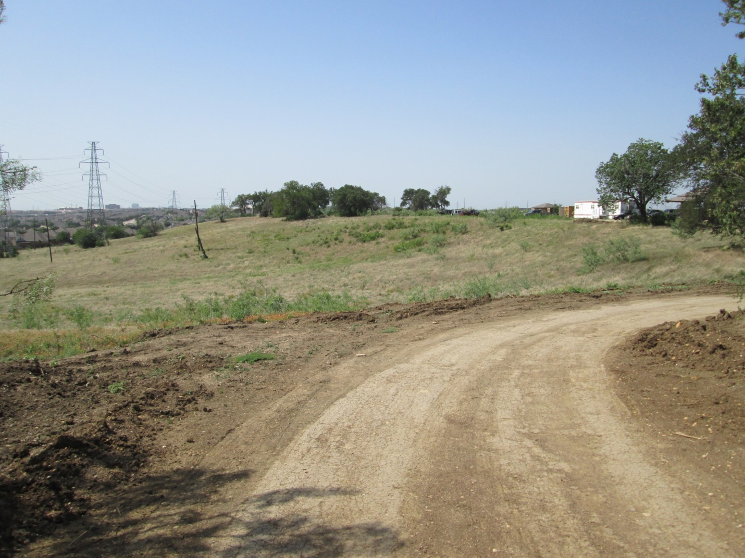

Figure 8. View of sinuous ridge formation in study area, west of Trinity River.

